An Integrated Project- to Enterprise-Level Decision Making Framework for Prioritization of Accelerated Bridge Construction

Quarterly Progress Report
For the period ending March 31, 2018

Submitted by:
PI- Alice Alipour, Ph.D., P.E.
Graduate Student- Ning Zhang

Affiliation: Department of Civil, Construction, and Environmental Engineering
Iowa State University
Ames, IA
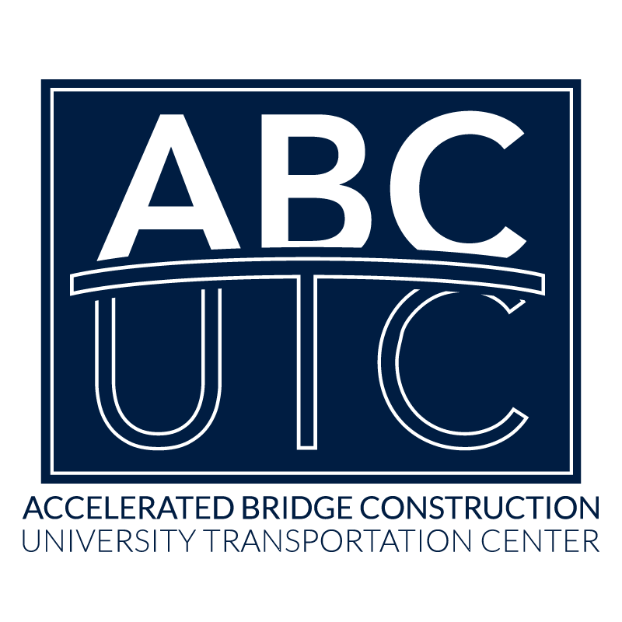

Submitted to:
ABC-UTC
Florida International University
Miami, FL

- PROPOSAL ABSTRACT:
Accelerated Bridge Construction (ABC) techniques have a great potential to minimize the traffic disruptions during the bridge repairs/replacements, promote traffic and worker safety, and also improve the overall quality of the built bridges. Despite the major advances in design and construction of ABC techniques, transportation agencies are still hesitant about using ABC techniques majorly due to perceived risks during construction and higher initial costs. Furthermore, the current decision process used to prioritize the candidate bridges for this type of construction techniques are solely based on the annual daily average traffic (AADT) and/ or the experience of the decision makers.
Extensive research has been conducted to ensure the structural integrity of the bridges using ABC. This is in addition to the developments in advancing the construction techniques to increase constructability and decreasing the time. However, to date, the overwhelming majority of the research has been in the structures field with little, if any, research devoted to constructability. SHRP2 and TRB research has proven that projects with a high degree of constructability are both faster and safer to build, which reinforces the aim of ABC. Dr. Gransberg was a member of the national task force that developed and published the FHWA ABC manual. Based on his experience, a decision tool for ABC project selection is needed that accounts for project-specific constructability of viable ABC design alternatives. Additionally, an enterprise-level decision model is required to provide the necessary justifications for the use of ABC techniques on an enterprise/network basis rather than project basis. This project aims to develop a decision-making algorithm that brings together the project-level decision process that involves the choice of optimized construction techniques together with the enterprise- level process that implements regional prioritization schemes considering indirect costs (such as drivers’ delay, economic impact, opportunity losses, economic growth, and social investments) in addition to the direct costs associated with implementation of the ABC techniques.
- DESCRIPTION OF RESEARCH PROJECT
B1. PROBLEM STATEMENT (Include project objectives)
Reduction of road closure times, traffic disruption and user costs, in addition to improvements in construction quality utilizing prefabricated elements, are all attractive qualities of the implementation of ABC techniques that encourage the transportation agencies to use the technique for repair and replacement projects. However, despite the extensive developments in effective design and construction of the ABC bridges, there are limited guidelines in planning phases for selection of the candidate bridges and the appropriate construction technique. A cursory review of the literature shows that there are two major decision strategies for prioritization of the bridges for ABC: the analytic hierarchy process (AHP) and the two-stage (level) decision making tool followed by the Iowa DOT that integrated AHP in the second stage of the decision-making process. These decision processes use readily available data from NBI (such as AADT, out-of-distance travel, and daily user costs) to qualitatively rate the bridges, then if a bridge is considered as a candidate for the ABC, the AHP method is used to qualitatively compare the options based on factors such as construction schedule, direct and indirect costs, and site constraints. This highlights the need for a holistic decision making algorithm that integrates the project-level parameters (such as the project completion time, site conditions, availability of specific resources, etc.) into an enterprise-level asset management framework (such as the effect of project in the region, accessibility and connectivity to critical facilities, the economic growth of the region, social return on investment, etc.). This is in addition to the need for a holistic framework that would be readily available in case of emergency conditions when there are multiple bridges affected by a regional natural hazard that would require immediate prioritization based on such factors as importance to the connectivity and accessibility of the network.
B2. ONTRIBUTION TO EXPANDING USE OF ABC IN PRACTICE
Accelerated bridge construction technology, initially reserved for routes with large AADT’s and/or critical thoroughfares, has significantly improved and increased in popularity. As a result, the benefits and economics of these techniques have gained traction in nearly all avenues of bridge replacement. However, one area of ABC technology in need of additional research is the development of a holistic decision making framework that can consider different aspects of the effects that such techniques could have in the overall growth of the region they are implemented in. These details will allow the ABC product, which is already of high quality and constructed under exceptional quality control, to further extend to applications that otherwise were not considered in traditional implementations of this technique.
B3. RESEARCH APPROACH AND METHODS
To develop a holistic decision making framework for selecting the candidates for ABC techniques, a multi-level optimization scheme that covers from project- to enterprise- levels is required. The research here will have specific focus on the operational
applications (such as the use of ABC for repair and replacement of deficient or obsolete
bridges) as well as extreme event applications (specifically when a large number of
bridges are affected by regional hazards such as floods, hazards, and hurricanes). To
achieve the goals of the project, three major steps will be taken: i) A multi-level decision
making framework covering scales from project- to enterprise-level will be developed, ii) the framework will be implemented for the state of Iowa bridges as a test-bed and its effectiveness in operational conditions will be evaluated, and iii) the application of framework will be extended for use as a decision-making tool for post-event emergency response to an extreme event affecting a region.
B4. DESCRIPTION OF TASKS TO BE COMPLETED IN RESEARCH
PROJECT
The proposed research will develop a holistic decision making framework for use in selection of candidate bridges for ABC in addition to the suitable techniques for each project. The following tasks will be performed to achieve the project goals:
Task 1- Literature review:
The project will start with a thorough literature review on: i) the available ABC decision
making techniques such as those used by Iowa DOT or Utah DOT, the AHP developed
by Oregon State University, and others, highlighting the benefits and shortcomings of
each technique, ii) review of the data and experiences from previous successful
implementations of ABC as part of the Every Day Counts initiative projects conducted by MoDOT, and iii) review of available articles on application of ABC for repair/replacement of bridges, increasing economic growth of the region through unconventional investments[1] and also applications to increase restoration speed, and consequently resilience of the system, after major regionally distributed extreme events [2, 3].
Status: Completed.
Task 2- Network-level planning framework for ranking and prioritization:
At this stage, a transportation network of the case-study area will be developed. Upon the formation of the network’s model using the graph theory, a risk-based approach will be used to estimate the likelihood of the bridge closures (partial or full) due to repair or replacement in operational conditions or the risk of closures due to extreme event conditions. The likelihood of repair/replacement will be estimated based on the inspection reports, NBI data and the bridge’s damage state. The damage state due to extreme conditions will be calculated based on probability of the occurrence of the event in addition to the vulnerability of the network to such events.
To establish the network-level planning framework, it is essential to identify
appropriate performance measures capable of comparing different states of the network
before and after closures. Among various measures proposed to date, three measures of
flow capacity, travel time, and network connectivity are proven to be the most appropriate ones. The flow capacity can be directly used to quantify the extent of change in the network right after closure (both partial and full). The travel time is a more holistic functionality measure that can estimate the level of performance of the network using more micro-level traffic data. The network connectivity can be defined as the ability to get from one node to another one. The connectivity measure is mostly suitable to ensure access to critical facilities while bridge is closed for repair. The proposed project takes advantage of all the three functionality measures to provide a comprehensive understanding of the state of resilience of the networks.
A comprehensive ranking scheme will be used to pin point the best bridge candidates. This ranking scheme will consider different aspects such as connectivity between different points of the network and accessibility to critical facilities (hospitals, fire stations, police departments), the effect of the downtime of the project on drivers’ delay, length of detours, opportunity loss/gain, the economic impact to the local economy (such as businesses, industry, or agriculture), and even the social effects. The prioritization framework will recursively communicate with the project-level data (Task 3) through a two-stage stochastic process to ensure an optimal prioritization scheme.
Status: Completed
Task 3 - Project-level framework for best construction method approach:
There are different construction techniques within the ABC that could be used depending on a number of parameters such as costs, availability of resources, the available time, possibility of full or partial closure, etc. that needs to be accommodated in a holistic decision making framework. For this purpose of this task, a matrix-based approach will be implemented that lists different factors and weighs them based on different performance measures from construction standpoint (such as time, cost, durability, constructability, and safety). These parameters will then feed into the prioritization scheme established in the network model (Task 2) to highlight the best ABC technique to be used in that site.
Progress in this cycle: A mixed-integer programming model that provides a balanced portfolio of construction techniques on bridge sites over a prioritizing selection of bridges at the network level. For this purpose, while a network-level scheme is used to select the bridges for rapid replacement based on their criticalities to the network, a project-level scheme accordingly is conducted to optimize the choice of accelerated construction techniques.
Status: Completed
Task 4 - Application to the test-bed and comparison with previous ABC projects:
After the development of the two-level decision making framework, it will be applied to a test-bed study (i.e. Iowa transportation network) and the results will be compared with the previous decision tool. Also the data from some extensive ABC projects such as the MoDOT “Safe and Sound” project, which delivered 802 rural bridge replacements in a single contract and set the standard for maximizing constructability in the ABC process, will be compared and the effects of such projects on the economic growth of the region will be evaluated.
Progress in this cycle: A smaller scale network model is established to show the applicability of the Mixed-integer approach for construction type/bridge prioritization.
Task 5 - Final report:
A final report will be developed that documents the entire project with an accompanying manual to use the framework.
Progress in this cycle: The draft of final report is completed and is being reviewed by the research team.
E.5. EXPECTED RESULTS AND SPECIFIC DELIVERABLES
The primary deliverable will be a holistic decision making framework using quantifiable measures.
- Zhang, N., Alipour, A., Coronel, L. “Application of Novel Recovery Techniques to Enhance the Resilience of Transportation Networks”, Accepted for publication in Journal of Transportation Research Record.
- Zhang, N. and Alipour, A. “Improved Resilience of the Transportation Network with Innovative Recovery Strategies”, Presented in 2018 ASCE SEI Structures Congress.
- Zhang, N. and Alipour, A. “A Project- to Network-Level Mixed-integer Programming Model for Prioritization of Accelerated Bridge Construction techniques”, Draft ready to be submitted to a journal.

